Irene and Vincent’s Relationship
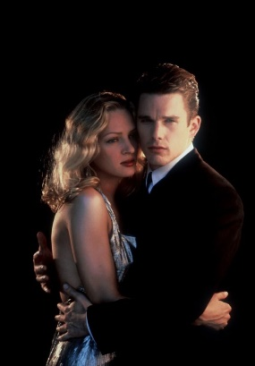

- An effective way to analyse a character is how he behaves and reacts to other characters and how they respond to him/her.
Irene and Vincent’s growing relationship is a significant plot line in Gattaca.

First Interaction
- We see them exchanging subtle glances while Vincent works at his cubicle. Irene, later approaches Vincent, and asks him how many rocket launches there are in a day, he answers 12, she then asks him how many he watches a day, knowing the answer, she pauses, “If you’re going to pretend you don’t care then don’t look up.”
What does this say about Vincent’s behavior/personality?
_______________________________________________________________________________________________________________________________________________________________________________________________________________
After Irene is Involved in the Investigation
- Irene steals a strand of Vincent’s hair (actually it was Jerome’s hair left at Vincent’s desk) and has it tested, she agrees with the person at the desk, ‘He is a catch.’ She seems disappointed that he is perfect.
- Irene and Vincent go outside together to discuss the case. They are on some terrace at Gattaca. Note the lack of trees or background so we have just a plain backdrop so we can focus on their interaction without distractions. She tells him that they found an invalid’s eyelash at the crime scene. When Vincent asks whose Irene replies, “Just some invalid’s.”
- Irene admits that she had Vincent tested, he looks mildly annoyed but not scared.
Irene: You’re everything they say you are and more. Vincent smiles: What about you Irene, you’re engineered like the rest of us.
Irene smiles: Not quite like the rest of you, an unacceptable likelihood for heart failure…
Vincent: Well if there is anything wrong with you I can’t see it from where I’m standing.
Irene: If you don’t believe me, here [passes him her hair]

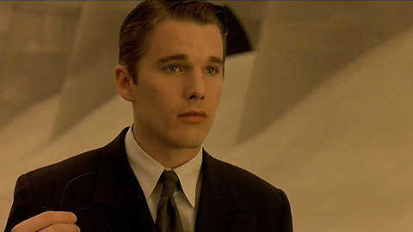

Vincent lets it blow out of his hands in the wind. There is an Extreme Close Up of the hair.
What is significant about Vincent letting the strand of hair blow away?
_______________________________________________________________________________________________________________________________________________________________________________________________________________
Vincent and Irene’s First Date
- Irene picks him up and looks up to see Jerome smiling down at her and doesn’t register this.
- While they are at the piano concert on their date there is close-up shots of their hands as they are about to hold hands.
- After the concert Vincent and Irene discuss the piano player. Vincent believes the piece was played well because the piano player had ‘heart’, Irene thinks it is because he had 12 fingers and the piece was designed for 12 fingers.

Is it significant that Irene believes that having being genetically engineered is key, not heart? Explain.
_______________________________________________________________________________________________________________________________________________________________________________________________________________
Motorway run
- Irene takes Vincent to her favourite place, parking on a motorway and running across the road, telling Vincent, “Quickly, or we’ll miss it.” He hesitates then dashes across the motorway in front the traffic, nearly blind without his contacts. She notices and the doubt sets in, “You’re eyes look different this morning Jerome.”
Second Date
- Vincent has two days left before his flight and asks Irene. They go to the Cavendish club. The scene opens with Irene drawing attention to her heart condition, by taking a pill in front of Vincent, and waiting for his reaction. He doesn’t.

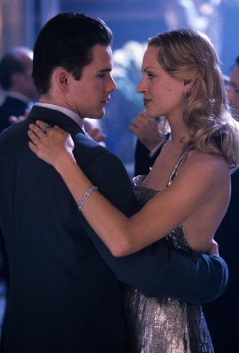

Irene: Luckier than some, unluckier than others.
Vincent: I might know something about that…

Irene cuts him off with playful joking, that he may have had a heart broken.
- She expresses her silly suspicion he is dating her because of the investigation, “You’re right…that’s silly.”
- Just as they are about to kiss whilst dancing there is a police raid. Irene witnesses Vincent punch a police officer 3 times, she screams and runs with him. He is dragging her. She falls. He drags her into a place they can’t be easily seen. When Irene gasps, “Don’t you understand, I can’t do that?” Vincent replies, “You just did.”
Explain the significance of Vincent’s response:
_______________________________________________________________________________________________________________________________________________________________________________________________________________
- When Anton screams “Vincent!” Irene asks, “Who is Vincent?” Vincent starts to say, “I…” Struggles, tries again and Irene stops him, “Don’t say anything.” They kiss.
- The next morning when Vincent’s explains the reason for the scars on his legs to Irene, she asks if he just made that up or it is what he said to everyone. He replies honestly, it is what he told everyone.
- Back at Gattaca, the same morning, Anton points out that Irene doesn’t really know the person she is dating at all.
After the Jig is Up
- Vincent chases Irene, not to apologise as much as explain that he is the example of how you can achieve your dreams despite your genetics.
- She cannot believe it and tells him it is impossible, and he replies that he is the living proof of what is possible. “They’ve got you looking so hard for flaws Irene, that you don’t see anything else.”

Click here for the clip about hair being tested.
Here is the piano concert clip
Here is the motorway dash
To see this clip, of the Chase Sequence click here
To see this clip of the Confrontation

